INTELLIGENT PRODUCT RECOMMENDATION & CUSTOMER PURCHASE PATTERN ANALYSIS
Report submitted as part of the internship program requirement for the degree of
BACHELOR OF TECHNOLOGY
IN
COMPUTER SCIENCE & ENGINEERING (AI & ML)
Submitted by
GALLA YAMINI DEVI (A24126552288)


DEPARTMENT OF CSE (AI & ML)

ANIL NEERUKONDA INSTITUTE OF TECHNOLOGY AND SCIENCES
(UGC AUTONOMOUS)
(Permanently Affiliated to AU, Approved by AICTE, and Accredited by NBA &NAAC with an ‘A+’ Grade)
SANGIVALASA, Bheemili Mandal, VISAKHAPATNAM – 531162
2025-2028

ANIL NEERUKONDA INSTITUTE OF TECHNOLOGY AND SCIENCES
(Affiliated to Andhra University)
SANGIVALASA, VISAKHAPATNAM -5351162
2023-2027

BONAFIDE CERTIFICATE
This is to certify that this Internship Report “INTELLIGENT PRODUCT RECOMMENDATION & CUSTOMER PURCHASE PATTERN ANALYSIS” from IBM is the Bonafide work of G YAMINI DEVI (A24126552288) of II/IV CSM, carried out Internship under my supervision.

REVIEWER CLASS TEACHER
Mr. S Lokesh Dr V. Tejaswini
Assistant professor Assistant professor
Department of CSE (AL & ML) Department of CSE (AL & ML)
ANITS ANITS

Head Of the Department
DR K SELVANI DEEPTHI
Department of CSE
(AL & ML) ANITS

ACKNOWLEDGEMENT

An internship is an important part of academic learning that provides an opportunity to gain practical knowledge and experience beyond the classroom. I would like to express my sincere gratitude to everyone who supported and guided me throughout my internship and helped me successfully complete this report and project.
First and foremost, I express my heartfelt gratitude to Dr. K. Selvani Deepthi, Head of the Department of Computer Science & Engineering (AI & ML), ANITS, for her valuable guidance, encouragement, and support throughout the internship.
I would also like to express my sincere thanks to the faculty members of the Department of CSE (AI & ML), ANITS, for their continuous encouragement and valuable suggestions during the internship period.
I am deeply grateful to IBM for providing me with the opportunity to undertake the Artificial Intelligence and Machine Learning Internship. The practical training, structured learning, and project-based approach helped me strengthen my knowledge of Python, data preprocessing, machine learning, data mining, clustering, association rule mining, and recommendation systems.
I would also like to thank my internship mentors, teammates, and friends for their guidance, cooperation, and support throughout the development of the project “Intelligent Product Recommendation & Customer Purchase Pattern Analysis.” Working on this project provided me with valuable practical experience in transaction data preprocessing, customer purchase-pattern analysis, the Apriori algorithm, frequent itemset generation, association rule generation, and product recommendation.
Finally, I express my sincere gratitude to everyone who directly or indirectly contributed to the successful completion of my internship and this report.
.

G YAMINI DEVI
A24126552288

TABLE OF CONTENTS
TOPIC | PAGE NO.
1. INTRODUCTIONS
1.1 Background | 8
1.2 Objectives | 8
1.3 Importance of the Project | 9
1.4 Scope | 10
2. TECHNOLOGY AND CONCEPT PROFILE
2.1 Artificial Intelligence and Machine Learning | 10
2.2 Clustering | 10
2.3 Association Rule Mining | 11
2.4 Apriori Algorithm | 11
2.5 Market Basket Analysis | 11
2.6 Recommendation Systems | 11
3. PROJECT OVERVIEW
3.1 Project Title | 12
3.2 Problem Statement | 12
3.3 Objectives | 13
3.4 Relevance of the Project | 13
4. LITERATURE REVIEW / THEORETICAL BACKGROUND
4.1 Product Recommendation Systems | 13
4.2 Customer Purchase Pattern Analysis | 13
4.3 Frequent Itemset Mining | 14
4.4 Market Basket Analysis | 14
4.5 Association Rules | 15
4.6 Clustering-Based Analysis | 15
5. METHODOLOGY
5.1 Data Collection | 16
5.2 Dataset Description | 16
5.3 Data Preprocessing | 16
5.4 Transaction Basket Formation | 17
5.5 Binary Encoding | 17
5.6 Apriori Algorithm | 18
5.7 Association Rule Generation | 18
5.8 Support | 19
5.9 Confidence | 19
5.10 Lift | 19
5.11 Rule Evaluation | 19
5.12 Recommendation Generation | 20
6. IMPLEMENTATION
6.1 System Workflow | 20
6.2 Data Loading | 21
6.3 Data Preprocessing | 21
6.4 Transaction Transformation | 22
6.5 Frequent Itemset Generation | 22
6.6 Association Rule Generation | 22
6.7 Rule Evaluation | 22
6.8 Recommendation Engine | 23
6.9 Recommendation Algorithm | 23
6.10 Python Implementation | 24
7. RESULTS AND DISCUSSION
7.1 Data Analysis | 24
7.2 Frequent Products | 24
7.3 Frequent Product Combinations | 25
7.4 Association Rules | 25
7.5 Support Analysis | 25
7.6 Confidence Analysis | 26
7.7 Lift Analysis | 26
7.8 Recommendation Results | 26
7.9 Graphical Analysis | 27
7.10 Discussion | 27
8. CONCLUSION AND FUTURE WORK
8.1 Summary | 28
8.2 Findings | 28
8.3 Limitations | 28
8.4 Future Scope | 29
9. PROJECT OUTCOMES
9.1 Technical Skills | 30
9.2 Analytical Skills | 30
9.3 Soft Skills | 30
9.4 Career Growth | 31
10. SOURCE CODE AND PROJECT STRUCTURE
10.1 Project Directory Structure | 31
10.2 Source Code | 31, 32
APPENDIX
A. Source Code | 34
B. Application Screenshots | 34
C. Certificate of Completion | 35

LIST OF IMAGES
Figure no. | Title | page No
Figure 3 | Project overview | 13
Figure 5.4 | Cleaned transaction records | 17
Figure 5.5 | Binary transaction matrix | 18
Figure 6.6 | Association rule confidence | 21
Figure 7.4 | Market Basket Analysis & Association Rules | 26
Figure 10.1 | Project Directory Structure | 32
Figure 10.2 | Transaction Dataset Loaded in the Application | 32
Figure 10.3 | Binary Transaction Matrix | 33
Figure 10.4 | Generated Frequent Itemsets and Association Rules | 33
Figure 10.5 | Product Recommendation Engine | 33
Figure 10.6 | Streamlit-Based Product Recommendation  Interface | 34
FIG 10.6 | Output | 35

1. INTRODUCTION
1.1 Background
The growth of e-commerce, retail platforms and digital marketplaces has resulted in the generation of large amounts of customer transaction data. Every purchase provides information about products selected by customers and the combinations in which those products are purchased.
A recommendation system uses available data to provide useful product suggestions to customers. Historical transaction records can be analysed to identify products that frequently occur together. These relationships can then be used to generate recommendations.
The project “Intelligent Product Recommendation & Customer Purchase Pattern Analysis” focuses on discovering such relationships using data mining and machine learning concepts.
The project applies Market Basket Analysis and Association Rule Mining to understand customer purchasing behaviour. The Apriori algorithm can be used to discover frequent item sets, while Support, Confidence and Lift can be used to evaluate the generated rules.
The overall process can be represented as:
Transaction Data → Data Cleaning → Data Transformation → Pattern Discovery → Rule Generation → Rule Evaluation → Recommendation
This workflow is also identified in the project case-study material.
1.2 Objectives
The major objectives of the project are:
- To understand customer purchase behaviour.
- To analyse historical transaction data.
- To preprocess and organize transaction data.
- To identify frequently purchased products.
- To identify frequently occurring product combinations.
- To perform Market Basket Analysis.
- To apply the Apriori algorithm for frequent-itemset mining.
- To generate association rules.
- To calculate Support, Confidence and Lift.
- To identify meaningful relationships between products.
- To develop a recommendation mechanism.
- To visualize important purchasing patterns.
- To derive useful business insights from transaction data.
These objectives follow the objectives specified in the case-study material.
1.3 Importance of the Project
Customers are often presented with a large number of products on online shopping platforms. Finding suitable products or complementary products can become difficult.
Businesses also possess historical transaction information but may not always be able to identify useful relationships manually.
The project provides a systematic approach for transforming transaction data into meaningful purchasing patterns.
The analysis can support:
- Personalized recommendations
- Cross-selling
- Product bundling
- Promotional planning
- Customer behaviour analysis
- Inventory planning
- Business decision-making
Market Basket Analysis is particularly useful for identifying products that repeatedly occur together in customer transactions.
1.4 Scope
The project can be applied in several domains, including:
- E-commerce
- Retail stores
- Supermarkets
- Online marketplaces
- Digital stores
- Product recommendation platforms
The system can accept transaction data, preprocess it, create transaction baskets, discover frequent itemsets, generate association rules and use the resulting rules for recommendations.

2. TECHNOLOGY AND CONCEPT PROFILE
2.1 Artificial Intelligence and Machine Learning
Artificial Intelligence enables computer systems to perform tasks that normally require intelligent decision-making.
Machine Learning is a branch of Artificial Intelligence in which systems learn patterns from data.
In this project, machine learning and data-mining techniques are used to analyze customer transaction information and discover purchasing relationships.
2.2 Clustering
Clustering is an unsupervised learning technique used to group similar data objects into clusters.
In customer purchase analysis, clustering can be used to group customers according to similar purchasing behaviour.
For example, customers may be grouped according to:
- Frequently purchased categories
- Purchase frequency
- Spending behaviour
- Product preferences
Clustering can therefore provide an additional understanding of customer segments.
2.3 Association Rule Mining
Association Rule Mining is a data-mining technique used to discover relationships between items.
An association rule has the general form:
A → B
where:
- A = Antecedent
- B = Consequent
For example:
Bread → Butter
In a product recommendation environment, the rule represents an observed relationship between products.
An association rule does not mean that purchasing A guarantees purchasing B. It represents a relationship discovered from transaction data.
2.4 Apriori Algorithm
Apriori is a frequent-itemset mining algorithm used to discover combinations of items that occur frequently in transactions.
The algorithm works by:
- Finding frequent individual items.
- Generating candidate item combinations.
- Calculating their support.
- Removing combinations that do not satisfy the minimum support.
- Generating larger itemsets from valid smaller itemsets.
- Continuing until no further frequent itemsets can be generated.
The frequent itemsets are then used for generating association rules.
2.5 Market Basket Analysis
Market Basket Analysis examines products purchased together in a transaction.
For example, a transaction may contain:
T-Shirt + Jeans + Shoes
Another transaction may contain:
T-Shirt + Jeans
If similar combinations occur repeatedly, the system can identify relationships between those products.
Market Basket Analysis can be used for recommendation generation, product bundling, promotions and cross-selling.
2.6 Recommendation Systems
A recommendation system suggests products or items that may be relevant to a customer.
In this project, product recommendations are generated from relationships discovered in transaction data.
The recommendation engine follows the basic structure:
Input Product → Matching Rules → Filtering → Ranking → Recommendation
The case-study material describes the recommendation engine using this workflow.
3. PROJECT OVERVIEW
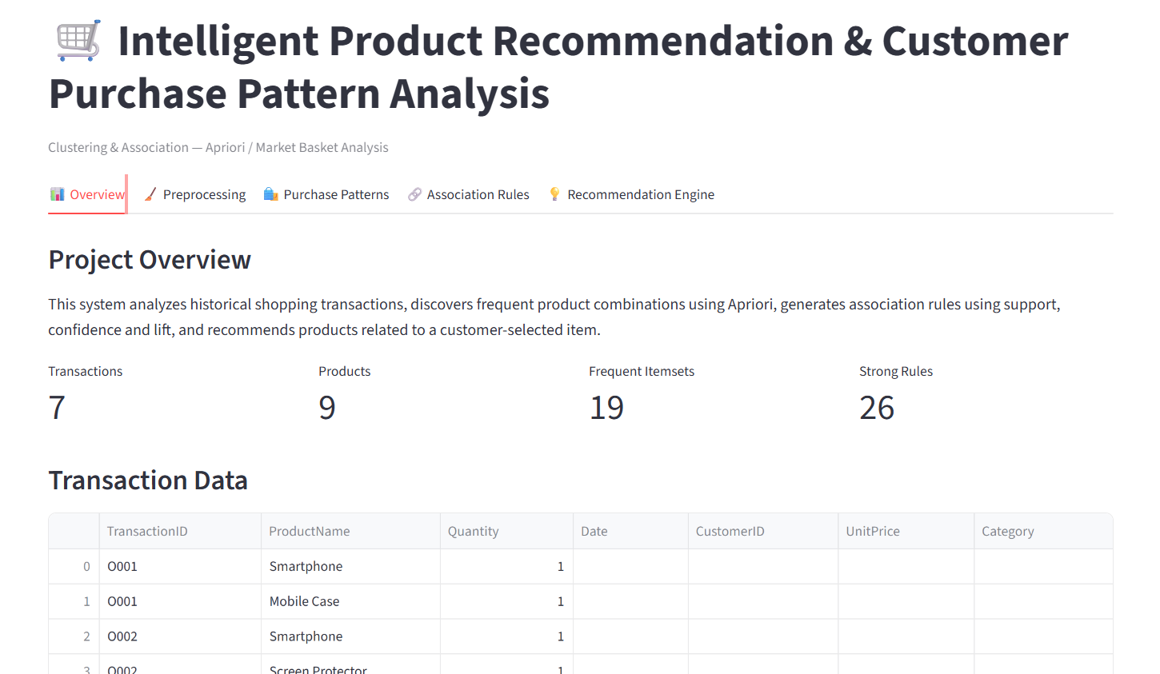
Fig 3:Project overview
3.1 Project Title
Intelligent Product Recommendation & Customer Purchase Pattern Analysis
3.2 Problem Statement
Modern e-commerce platforms contain thousands of products. Customers may find it difficult to identify products that are related to their current selection.
At the same time, businesses generate large amounts of historical transaction data. The challenge is to discover meaningful relationships within this data and convert them into useful recommendations.
The project addresses this problem by analyzing transaction data using frequent-itemset mining and association-rule techniques.
3.3 Objectives
The project aims to:
- Analyze customer transactions.
- Discover frequent products.
- Discover frequent item combinations.
- Apply Apriori.
- Generate association rules.
- Calculate Support, Confidence and Lift.
- Analyze purchasing patterns.
- Build a recommendation mechanism.
3.4 Relevance of the Project
The project is relevant to modern data-driven businesses because customer transaction data can contain useful information about purchasing behaviour.
The discovered relationships can help businesses understand which products are frequently purchased together and use this information for recommendation and cross-selling strategies.

4. LITERATURE REVIEW / THEORETICAL BACKGROUND
4.1 Product Recommendation Systems
Recommendation systems are designed to provide relevant product suggestions based on available information.
Historical transaction data provides one possible source of information for recommendation generation.
A recommendation system can analyze previous transactions to identify repeated product combinations and recommend associated products.
4.2 Customer Purchase Pattern Analysis
Customer Purchase Pattern Analysis studies the behaviour represented by historical purchase records.
The analysis can identify:
- Frequently purchased products
- Frequently purchased categories
- Repeated product combinations
- Customer preferences
- Product relationships
This information can be converted into business insights.
4.3 Frequent Itemset Mining
A frequent itemset is a group of products that occurs frequently in a transaction dataset.
For example:
{Shirt}
{Shirt, Jeans}
{Shirt, Jeans, Shoes}
The frequency of each itemset is measured using Support.
Apriori can be used to discover such frequent itemsets.
4.4 Market Basket Analysis
Market Basket Analysis represents each transaction as a basket containing the products purchased together.
For example:
Transaction | Items
T1 | A, B
T2 | A, C
T3 | A, B, C
T4 | B, C
The objective is to identify repeated combinations and relationships.
4.5 Association Rules
Association rules describe relationships between products.
General form:
Antecedent → Consequent
Example:
A → B
The rule can be evaluated using Support, Confidence and Lift.
4.6 Clustering-Based Analysis
Clustering can be used alongside association analysis to understand groups of customers with similar purchasing behaviour.
For example, customers may be grouped into clusters based on their purchasing characteristics.
The resulting customer groups can provide additional information for personalized recommendation systems.

5. METHODOLOGY
5.1 Data Collection
The first stage is collecting transaction information.
The dataset may contain fields such as:
- Transaction ID
- Product ID
- Product Name
- Quantity
- Date
- Customer ID
- Unit Price
- Category
These fields are identified in the project case-study dataset description.
5.2 Dataset Description
The transaction dataset represents customer purchases.
Each transaction contains one or more products purchased by a customer.
The Transaction ID is used to identify which products belong to the same purchase.
The Product Name or Product ID identifies the purchased product.
5.3 Data Preprocessing
Raw transaction data may contain missing values, duplicate records or invalid information.
Preprocessing includes:
- Checking missing values.
- Removing duplicate records.
- Handling invalid values.
- Filtering inappropriate records.
- Organizing products according to transactions.
- Preparing the data for basket analysis.
These preprocessing operations are described in the case-study material.
5.4 Transaction Basket Formation
After preprocessing, products are grouped according to Transaction ID.
Example:
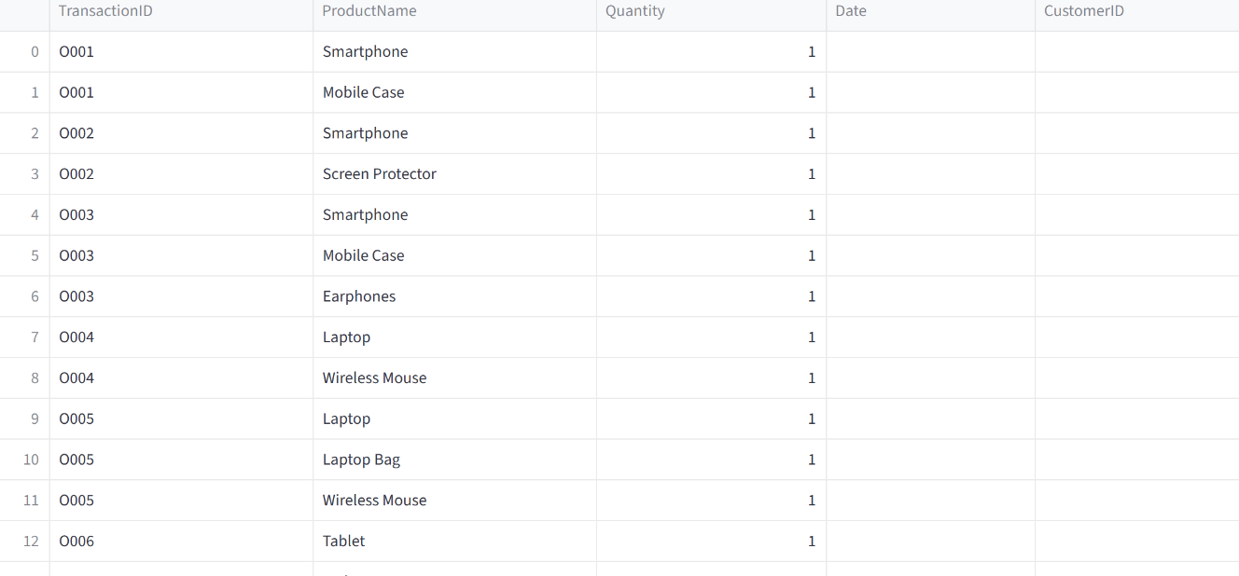
FIG 5.4: Cleaned transaction records
Each row represents one customer purchase basket.
5.5 Binary Encoding
For Apriori analysis, transaction data can be converted into a binary representation.
Example:
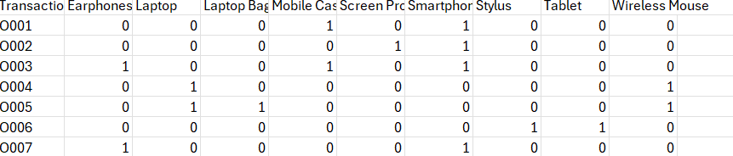
FIG 5.5: Binary transaction matrix
Here:
1 = Product purchased
0 = Product not purchased
This allows frequent-itemset algorithms to process transaction baskets.
5.6 Apriori Algorithm
The Apriori algorithm identifies frequent itemsets using a minimum-support threshold.
The basic process is:

Transaction Data
↓
Frequent 1-Itemsets
↓
Candidate 2-Itemsets
↓
Frequent 2-Itemsets
↓
Candidate 3-Itemsets
↓
Frequent 3-Itemsets
↓
Association Rules
The algorithm eliminates itemsets that do not satisfy the minimum support requirement.
5.7 Association Rule Generation
After frequent itemsets are obtained, association rules are generated.
For example:
A → B
B → C
A,B → C
The rules are evaluated using Support, Confidence and Lift.
5.8 Support
Support indicates how frequently an item or item combination occurs in the entire transaction dataset.
Formula:
Support(A) = Transactions containing A / Total Transactions
For two items:
Support(A, B) = Transactions containing both A and B / Total Transactions
Support helps identify frequently occurring combinations.
5.9 Confidence
Confidence measures how frequently B occurs when A occurs.
Formula:
Confidence(A → B) = Support(A,B) / Support(A)
For example, if 100 transactions contain A and 70 of those transactions also contain B:
Confidence = 70 / 100 = 70%
Confidence therefore provides an indication of the reliability of the rule.
5.10 Lift
Lift measures the strength of the relationship between A and B.
Formula:
Lift (A → B) = Confidence (A → B) / Support(B)
Interpretation:
- Lift > 1: Positive association
- Lift = 1: Approximately independent
- Lift < 1: Negative association
Support, Confidence and Lift are the principal measures described in the project case study for evaluating association rules.
5.11 Rule Evaluation
Not every generated rule is useful.
Rules can be evaluated using minimum thresholds for:
- Support
- Confidence
- Lift
Weak rules can be removed while stronger relationships can be retained for recommendation generation.
5.12 Recommendation Generation
The recommendation engine uses evaluated association rules.
The process is:
Customer Selects Product
↓
Search Matching Association Rules
↓
Filter Rules
↓
Rank Recommendations
↓
Display Recommended Products
For example, if the selected product is A and a strong rule exists:
A → B
then B can be considered as a recommendation.
6. IMPLEMENTATION
6.1 System Workflow
The complete system workflow is:
Data Collection
↓
Data Preprocessing
↓
Transaction Formation
↓
Binary Encoding
↓
Apriori Frequent Itemset Mining
↓
Association Rule Generation
↓
Support, Confidence & Lift
↓
Rule Filtering
↓
Recommendation Engine
↓
Product Recommendation
This follows the algorithmic workflow described in the case study.

6.2 Data Loading
The transaction dataset is loaded into the analysis environment.
Python libraries such as Pandas can be used to read and manipulate the dataset.
The dataset is examined to understand:
- Number of transactions
- Product information
- Missing values
- Duplicate records
- Data types
6.3 Data Preprocessing
The dataset is cleaned before applying the Apriori algorithm.
The preprocessing stage ensures that the transaction data is properly organized and suitable for analysis.
6.4 Transaction Transformation
Transactions are grouped according to their Transaction IDs.
Each transaction becomes a basket of products.
The basket representation is then transformed into binary form for frequent-itemset mining.
6.5 Frequent Itemset Generation
The Apriori algorithm is applied to the encoded transaction dataset.
The algorithm identifies frequent itemsets according to the selected minimum-support threshold.
6.6 Association Rule Generation
Association rules are generated from the frequent itemsets.
Each rule contains:
Antecedent → Consequent
The generated rules are then evaluated using the selected metrics.
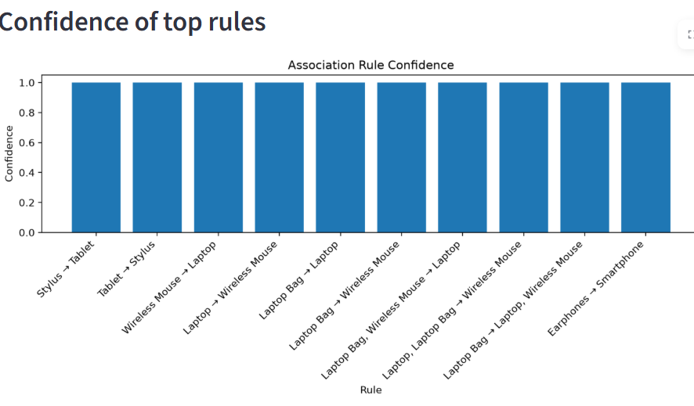
FIG 6.6:Association rule confidence
6.7 Rule Evaluation
The system calculates:
- Support
- Confidence
- Lift
Rules that do not satisfy the required criteria can be filtered out.
6.8 Recommendation Engine
The Recommendation Engine accepts a selected product as input.
It searches the rule database for matching antecedents.
Matching rules are filtered and ranked.
The consequent products are then returned as recommendations.
The case-study recommendation engine follows the same basic sequence of receiving a product, searching matching rules, filtering, ranking and displaying recommendations.
6.9 Recommendation Algorithm
Algorithm
- Load transaction data.
- Preprocess the dataset.
- Group products by transaction.
- Create transaction baskets.
- Convert baskets into binary representation.
- Apply the Apriori algorithm.
- Generate frequent itemsets.
- Generate association rules.
- Calculate Support.
- Calculate Confidence.
- Calculate Lift.
- Remove weak rules.
- Receive the selected product.
- Search for matching association rules.
- Extract consequent products.
- Rank the recommendations.
- Display recommended products.
This algorithm is based on the sequence specified in the project case-study material.
6.10 Python Implementation
Python can be used for implementing the data-analysis portion of the project.
Important libraries include:
- Pandas – Data manipulation
- NumPy – Numerical operations
- MLxtend – Frequent-itemset and association-rule mining
- Matplotlib – Data visualization
- Jupyter Notebook / VS Code – Development environment
The case-study material identifies Python, Pandas/NumPy, MLxtend, Apriori and Matplotlib as suitable software requirements.

7. RESULTS AND DISCUSSION
7.1 Data Analysis
The first stage of analysis involves examining the transaction dataset.
The data can be analysed to identify:
- Frequently purchased products
- Product frequencies
- Transaction frequencies
- Product combinations
- Customer purchase patterns
7.2 Frequent Products
The frequency of individual products can be calculated.
Products with higher transaction frequency may be considered popular products within the analyzed dataset.
[Insert Graph – Top Frequently Purchased Products]
7.3 Frequent Product Combinations
The system identifies combinations of products that occur together.
For example:
Product A + Product B
Product A + Product C
Product B + Product C
The frequency of these combinations can be visualized using bar charts.
[Insert Graph – Frequent Product Combinations]
7.4 Association Rules
After frequent itemsets are identified, association rules are generated.
Example format:
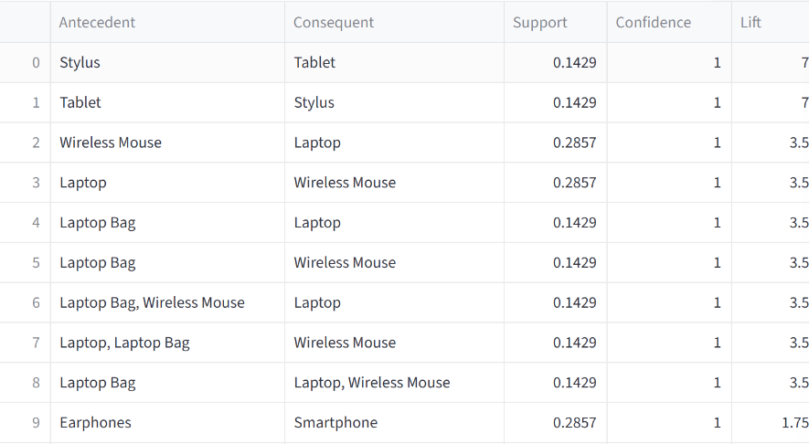
FIG 7.4: Market Basket Analysis & Association Rules
The actual rules depend on the transaction dataset used for the project.
7.5 Support Analysis
Support indicates how frequently a particular item or combination occurs across all transactions.
A higher support value indicates that the combination appears in a larger proportion of the dataset.
[Insert Graph – Support Values]
7.6 Confidence Analysis
Confidence measures the likelihood of the consequent appearing when the antecedent occurs.
A rule such as:
A → B
with high confidence indicates that B frequently occurs in transactions containing A.
[Insert Graph – Confidence Values]
7.7 Lift Analysis
Lift measures the strength of the relationship between two products.
A lift greater than one indicates a positive association according to the project methodology.
[Insert Graph – Lift Values]
7.8 Recommendation Results
The Recommendation Engine uses the evaluated association rules to identify related products.
For a selected product:
Input Product
↓
Matching Rules
↓
Filtered Rules
↓
Ranked Products
↓
Recommendations
The recommendations can be displayed to users as complementary or related products.
7.9 Graphical Analysis
Graphs can be used to represent:
- Product frequency
- Frequent itemsets
- Support
- Confidence
- Lift
- Number of association rules
- Recommended products
Visualizations make the identified patterns easier to understand.
7.10 Discussion
The analysis demonstrates how transaction data can be transformed into meaningful purchasing relationships.
The combination of Apriori and association-rule analysis provides a structured method for discovering products that frequently occur together.
The recommendation engine can then use these relationships to generate product suggestions.
The case study identifies applications such as recommendations, bundling, promotions, cross-selling, inventory planning and customer behaviour analysis.
8. CONCLUSION AND FUTURE WORK
8.1 Summary
The project “Intelligent Product Recommendation & Customer Purchase Pattern Analysis” demonstrates the use of data-mining and machine-learning concepts for analyzing customer transactions.
The project studies customer purchasing behaviour through Market Basket Analysis and Association Rule Mining.
The Apriori algorithm is used to identify frequent itemsets, while Support, Confidence and Lift are used to evaluate association rules.
The resulting relationships provide the foundation for an intelligent Recommendation Engine.
8.2 Findings
The project demonstrates that:
- Transaction data can be used to identify purchasing patterns.
- Frequently purchased products can be identified.
- Products purchased together can be discovered.
- Apriori can be used for frequent-itemset mining.
- Association rules can represent product relationships.
- Support measures frequency.
- Confidence measures rule reliability.
- Lift measures the strength of association.
- Evaluated rules can support product recommendations.
8.3 Limitations
The project has some limitations:
- Recommendation quality depends on the quality and size of the transaction dataset.
- Apriori can become computationally expensive with very large datasets.
- Association rules primarily capture relationships between purchased items.
- New products with little or no transaction history may be difficult to recommend.
- Results depend on selected minimum-support and confidence thresholds.
- Customer preferences may change over time.
8.4 Future Scope
The project can be extended by implementing:
Customer Segmentation
Clustering can be used to group customers according to purchasing behaviour.
Hybrid Recommendation
Association-rule recommendations can be combined with collaborative and content-based recommendation methods.
Real-Time Recommendations
The system can be integrated with an online shopping platform to generate recommendations dynamically.
Deep Learning
Advanced neural-network-based recommendation models can be explored for larger datasets.
Personalized Recommendations
Recommendations can be customized according to individual customer history and preferences.
Large-Scale Data Processing
Technologies for large-scale data processing can be incorporated when transaction volumes become very large.
Advanced Analytics
Future versions can analyze:
- Customer lifetime behaviour
- Product popularity
- Seasonal purchasing
- Customer segments
- Purchase frequency
- Product-category relationships
9. PROJECT OUTCOMES
9.1 Technical Skills
The project provides knowledge of:
- Python programming
- Data preprocessing
- Pandas
- NumPy
- Machine Learning concepts
- Clustering
- Association Rule Mining
- Apriori
- Market Basket Analysis
- Support
- Confidence
- Lift
- Data visualization
- Recommendation systems
9.2 Analytical Skills
The project improves the ability to:
- Understand transaction datasets.
- Identify useful variables.
- Clean and preprocess data.
- Analyze purchasing patterns.
- Interpret association rules.
- Compare Support, Confidence and Lift.
- Convert analytical results into recommendations.
9.3 Soft Skills
The project also develops:
- Problem-solving
- Logical thinking
- Research skills
- Documentation
- Presentation skills
- Time management
- Technical communication
9.4 Career Growth
The project provides practical exposure to data analytics, machine learning and recommendation-system concepts.
The knowledge gained can support future work in areas such as:
- Data Science
- Machine Learning
- Artificial Intelligence
- Data Analytics
- Business Intelligence
- Recommendation Systems
10.Source Code and Project Structure
10.1 Project Directory Structure
The project is implemented as a Python-based data mining and recommendation application using Streamlit for the user interface. The project follows a simple and organized structure containing the application source code, transaction dataset, dependency file, and project documentation.
10.2 Source Code
The following listings show representative sections of the Python implementation, including the Streamlit application setup, transaction preprocessing, binary transaction matrix generation, Apriori algorithm, association-rule generation, and recommendation engine.
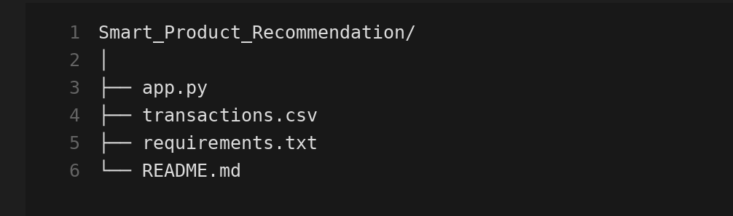
Figure 10.1: Project Directory Structure
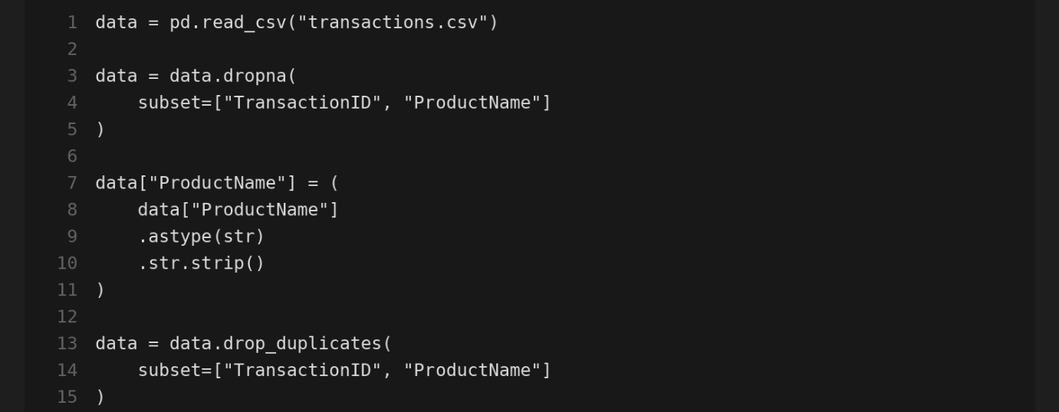
Figure 10.2: Transaction Dataset Loaded in the Application
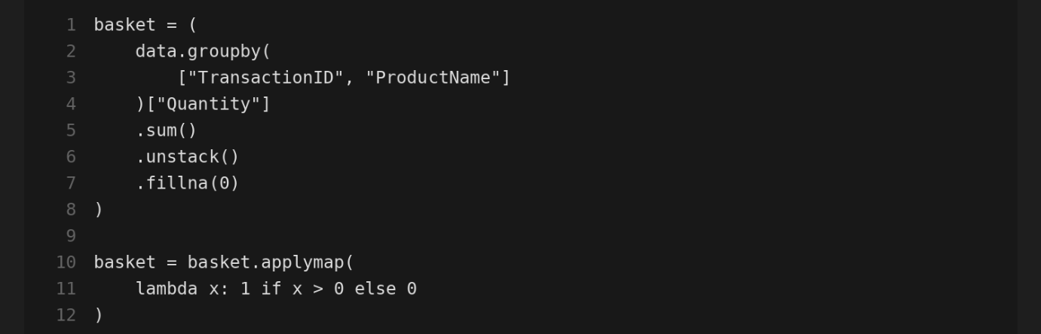
Figure 10.3: Binary Transaction Matrix
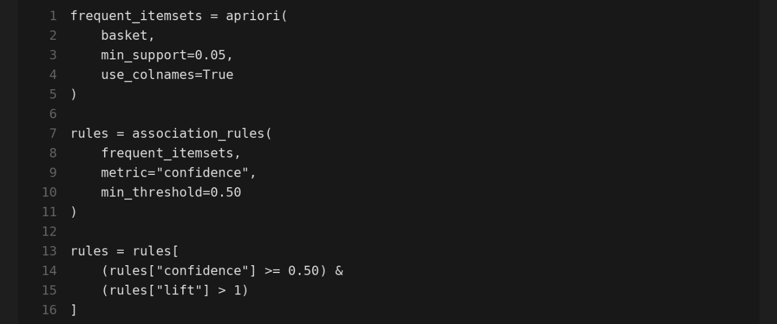 Figure 10.4: Generated Frequent Itemsets and Association Rules
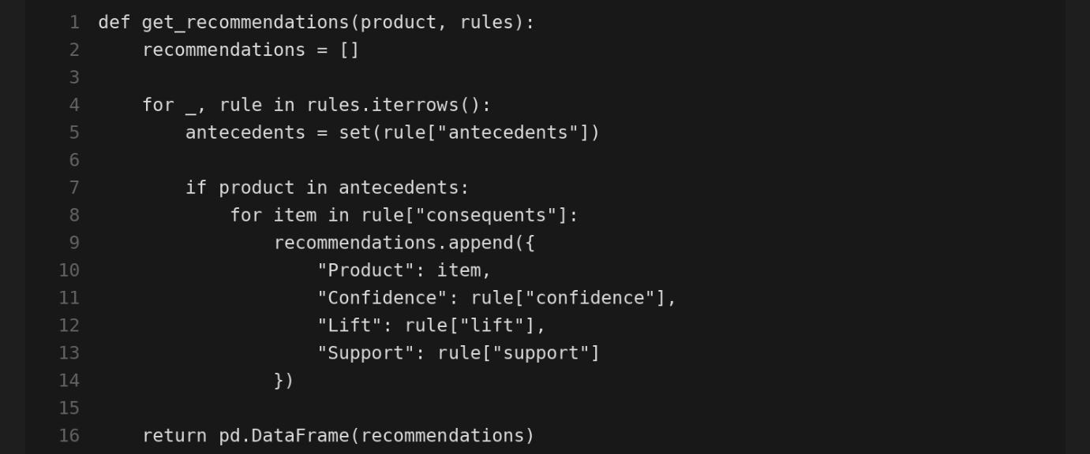
Figure 10.5: Product Recommendation Engine
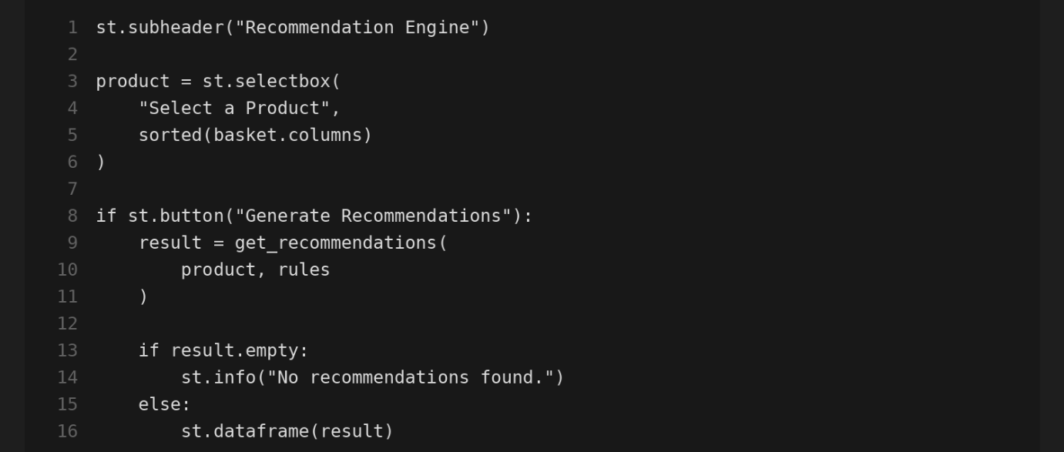
Figure 10.6: Streamlit-Based Product Recommendation Interface
Appendix
A. Source code
The complete source code for this project is available at the following locations:
• GitHub Repository : ____________________________
• Live Deployment Link: ____________________________
B. Application Screenshots
Screenshots of the key application screens are shown below.
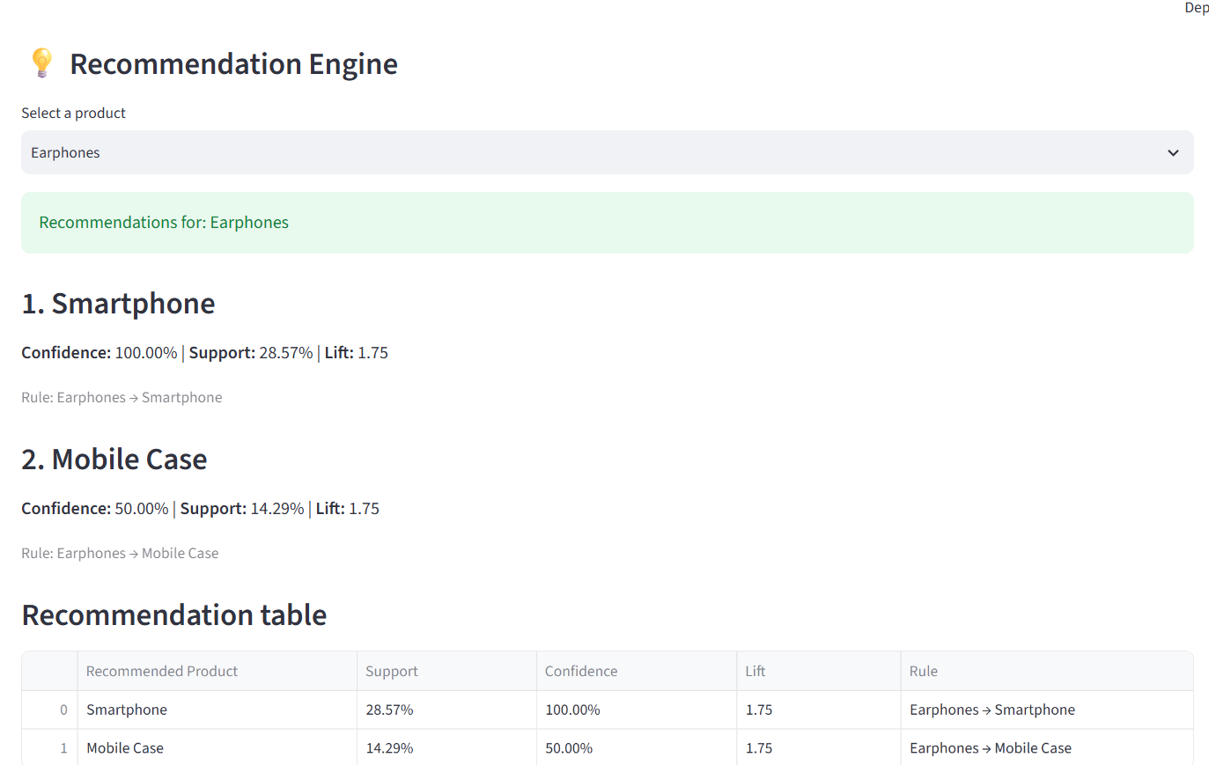
FIG 10.6 : Output

C. Certificate of Completion:
